THANET INDOOR BOWLS CLUB - COVID-19 RESTRICTIONS
Members Instructions – Use of Club Facilities
These Instructions are subject to change at any time
Members must Pre-book, up to 7 days in advance by phone. The telephone number is 01843 227083
Depending on demand, members may be assigned rinks and groups on arrival at the Club.
Face coverings are to be used at all times within the Club. No Covering, No Entry. - (Masks are on sale at the Club)
Members will have their temperatures taken prior to entering the Club using a non-contact electronic thermometer. Those with temps at or above 38C will not be allowed entry.
Members are to follow the one-way system and signage at all times to ensure social distancing is maintained where ever possible
Do not move any chairs or tables.
Please arrive wearing the appropriate bowls attire (casual wear permissible) and minimise the number of bags etc. carried into the Club.
Changing Rooms will be CLOSED. On entering the Club for the first time members are to collect their bowls equipment from their lockers on a ‘one in, one out ’ basis.
Members are to use the Restaurant area to change their shoes etc. and are to take their belongings to the rink.
The Gents toilet and the Disabled Toilet will be available to Members on an ‘one in, one out ’ basis.
Members waiting to commence bowling are to socially distance in the lounge area until ALL rinks are clear and players have left the rinks.
Hand gel is available around the Club, use on entry to Club and repeat application frequently.
Enhanced cleaning regimes are in force, please help staff by restricting movement around the Club.
After leaving the rink members are to change their bowls shoes in the Restaurant and take their bowls equipment home with them.
Entrance - Members are to use the Main Entrance only.
Exits - Members are to leave the Club via the Restaurant. Those with mobility issues may only use the Main Entrance if escorted by a member of staff.
Playing Bowls
These Instructions are subject to change at any time
Bowling sessions will be Monday-Friday and Sunday as follows:-
09.00 – 11.00, 11.30 – 14.00 hours
Evening Sessions Monday and Thursday 19.00 – 21.30 hours (additional evening sessions will be added if demand is there).
Players must use the appropriate entry steps and exit ramp to access the rink area.
Players on Rinks 1, 3, 5 and 7 will commence bowling from the lounge end.
Players on Rinks 2,4,6 and 8 will commence from the Score Board end.
For an initial period the following playing formats will be allowed, Singles, Pairs and Triples. Full Rinks will not be allowed at this stage.
Mats and Jacks will be disinfected prior to use and placed in a sanitised box. A lead person from each rink will collect and return the box and equipment to Reception.
Players are to touch their own woods only. One Lead player and One Skip only will pick up mats and re-spot the Jack after each end.
The same players are to update scoreboards – sanitising their hands after each use.
‘T’ marks are placed 4 metres from the ditch. Mats must be placed on the ‘T’ and the Jack placed at the desired position by the Skip using foot only, one Jack each end.
The new 4m ‘T’ will be the maximum length
Jacks are to be replaced in the original position if dislodged.
Measuring to be done using own measure – do not touch woods.
Those players wishing to have refreshments are to use the Order form placed in the box of bowls equipment and take the completed order to Reception. Drinks will then be brought to the rink.
Social distancing is to be maintained at all times, especially when changing ends.
Please see attached diagram explaining safe positioning of players

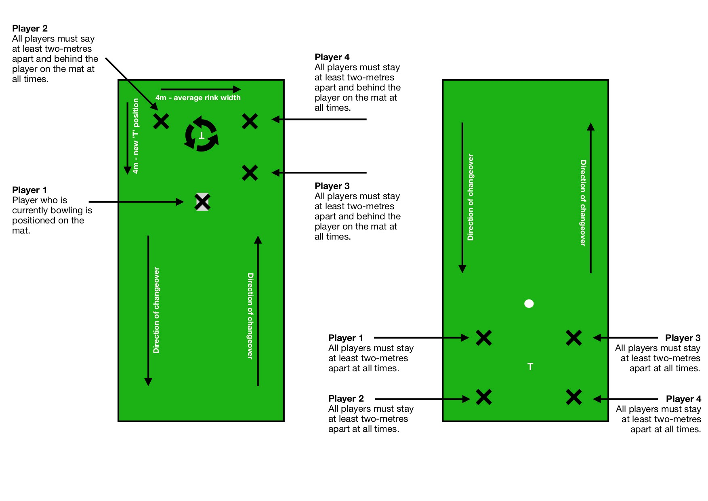

IRT/25th July

