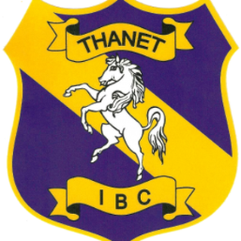

Dear Member

30th July 2020

2020 – 2021 Membership Forms

Welcome back to Indoor Bowling after what has seemed like an eternity.

During the last 4 months, the enforced closure of the Club has resulted in us receiving no income since the end of March. Cash-flow is essential for all businesses and without this they can’t survive. The Directors have had great difficulty in keeping the Club afloat during this period and without the help of the Government in the form of the Furlough Scheme and a grant we would have struggled to survive.

In order to place the Club on a more secure financial footing the Directors have decided to make small increases to the fees for next year. Annual and Winter membership fees are to increase by £10 (still below 2018 prices) and Green fees will increase by 50p., the first change for 3 years. Ratification of these increases will be at the Annual General Meeting in September.

Due to the current Government restrictions we have not been able to publish a programme of external fixtures for the Winter season yet. The EIBA and County Associations have yet to decide on whether there will be any County Leagues next season.

We will, however, endeavour to arrange friendlies with local clubs, run as many internal leagues, competitions and social events as we can. Details of these will be advertised in the Club shortly.

We trust that the various Covid-19 health and safety precautions we have put in place provides a safe environment in which to enjoy your bowls – look out for the internal leagues that will hopefully start during August and run through to the end of September.

Yours Faithfully

Ian Thorpe
Chairman

