centreFORWARD

Welcome back
I hope that you have had a lovely summer and that it has not been too hot !
With the nights drawing in it is time to plan for the winter and I include with this newsletter the Membership Forms for you to complete.
Income raised from your subscriptions are essential for the Club and provide us with much needed revenue to support you in your bowls and to provide excellent facilities for you to enjoy.
Please complete these forms and return to the Club Reception so that we can organise the various leagues, fixtures and competitions.
Finances
The past year has been a year of recovery and I am pleased to report that the Club is on a sound financial footing following the Covid pandemic.
Our results for the last financial year have been prepared by our accountants and confirm that we are well on the road to recovery.
I will provide a full, detailed breakdown of the accounts at our AGM on Friday 2nd September starting promptly at 7.00 p.m.
During the summer we have commenced a programme of long overdue improvements, upgrading the Ladies and Gents toilets and carrying out repairs to the roof and guttering. During the next couple of months the disabled toilets will be renovated, the exterior of the building will be painted, emergency doors will be replaced and other running repairs to the bar, cellar and restaurant completed.
You will notice that Annual, Seasonal and locker fees have been held at previous year’s prices despite external financial pressures on the Club. We are not immune to the increases to energy costs, wages, food, drink and other prices and, last winter, we had to absorb additional electricity costs of over £1000 per month – hence the regrettable increase of 50p on Green Fees. These additional fees only recover approx. 50% of these additional costs but with careful management we do not expect any further major changes to current prices.
Membership
It is hoped that you will support the Club in the coming year and encourage friends, family and neighbours to join us. This will enable us to continue with the development of your Club.

Autumn Calendar
We have put together a full programme of Bowls and Social events for you to enjoy.

Social Dates for your diary :-
This Autumn marks the 90th Anniversary of Indoor Bowls in Thanet and to mark this milestone we are holding a Fun Day on Saturday, 24th September. Academy FM, our local radio station, will be broadcasting live from the Club and providing music throughout the day.
A day long competition between TIBC and outdoor Clubs in Thanet will be held and there will be free taster sessions for anyone wishing to try bowls for the first time.
Our new Shop – the TIBC Emporium, will be open for business, displaying hand-made Arts, Crafts and other products produced locally.
Our bar and restaurant will be open offering everything from a simple snack to a full meal.
Other surprises are being planned so please come along and support the day.
Saturday 8th October – Ricky Fontayne’s Dreamcoats and Petticoats show will entertain us with a night of rock and roll and a basket meal will be provided.
Saturday 19th November – Nick Kelly will entertain us with a wide range of country classics, rock and roll and dance music, again accompanied by a basket meal.
For our New Year’s Eve Gala Night the ever popular Nick Bosworth will help welcome in the new year and we will be providing our sumptuous gala buffet.
In addition to the above the Club will be hosting 2 afternoons of Gershwin, accompanied by a light tea and scones. These will be held on 22nd September and 27th October – ring 0800 7813452 for tickets

Monthly Quiz
Our, ever popular Monthly Quizzes continue and these are held on the last Friday of the month, starting at 7 p.m. and punctuated with a fish and chip supper. The next dates are :-
26th August, 30th September and 28th October so get your friends together, book your table and test your general knowledge.

Bowls Matters !!!
Our early morning Roll-Up sessions are proving ever popular with all rinks in regular use. Come along and join in these friendly sessions.
For those of you who have been playing in roll ups regularly – have you thought about playing in Club matches and friendlies ?????
They are not as daunting as you may think and are just as enjoyable. Team mates will give you all the support you need so give it a try.
Our next summer mixed friendlies are :-
14th September - Prince Arthur
17th September - Oyster
1st October - Swale
In addition to the internal leagues and competitions Mick Mooney will be running the ever popular Top Score on Mondays and Fridays at 2.0 p.m.
The Men’s Kent League programme starts in October, the full programme is being finalised and will be available at the Bowls AGM on Friday 2nd September at 7.00 p.m
The first fixtures are :-
8th October - Oyster
NEXT QUIZ NIGHT
FRIDAY 26TH AUGUST
PLEASE BOOK YOUR TABLE & ORDER FOOD AT THE BOWLS CLUB BY WEDNESDAY 24TH AUGUST
9th October - Stone Lodge

Summer Finals Weekend
All our summer competitions are nearly complete and our Finals Weekend to determine the winners will be held on :-
10th & 11th September
so come along and support those taking part.

New Members / Training Programmes
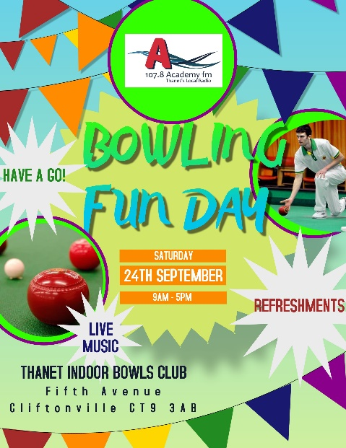
The ‘Bowls4Free’ programme for new bowlers continues to attract new members and our particular thanks go to Kevin Watts, Dave Hamilton and other volunteers who have given up their time to put new bowlers through their programme of training.
This programme is bringing through our next generation of bowlers and is helping bolster membership. Names for our next tranche of coaching are currently being taken so invite friends and family to try their hand at bowling with 4 weeks of free instruction.

Club Shop
We are re-organising our shop in order to increase Club revenue. As mentioned earlier we have split the shop and, in addition to the sale of regular bowls equipment, we welcome the opening of the TIBC Emporium in September, selling hand-made craft items produced by local traders at extremely competitive prices. So get your orders in early for unique Christmas presents.

Club Shirts
Stocks of Club Shirts are available. These shirts are normally priced at £18 but will be on sale for £14.40

Web Site
Our Website is available and we place all the current news, fixtures, league tables, events and notices on there to keep you abreast of Club news.
Just go to the ‘Events’ section of the site and sign in using the Club password, this is available from reception.
Our Website can be found at :- https://thanetibc.com/

